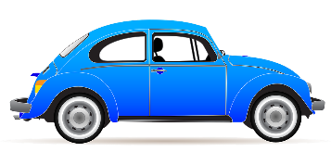
Car Advertisement Assignment– Planning Page

Name: _____________________

Your Task:
Now that you have learned about each of the features and forms, you are in charge of creating an advertisement to sell a car. You must first choose an important person
Ex) Superman, Beyonce…etc. to sell your car. Use the features and forms in the table below to construct your advertisement and make it more exciting!

Requirements:
- Title at the top of your page (max 5 words).
- A 1 sentence introduction.
- At least 1 sentence for each of the features and forms that you learned (see the planning table below).
- 1 picture of the car that your person of choice is selling.
- A completed peer and self-assessment
SKILL | MY PLAN
Hyperbole (exaggeration)
Simile
(like & as)
Metaphor
(no like & no as)
Imagery
(sensory details)
Diction – Word-Choice (vocabulary)
Sound – Onomatopoeia (effects)
Who is selling your car?

Reminder – USE TIME AND TECHNOLOGY RESPONSIBLY!

