Elements of a Short Story
Narrator:
__________________________________________________________________________________________________________________________________________________________________________________________________________________________________________
Character:
__________________________________________________________________________________________________________________________________________________________________________________________________________________________________________
Plot:
__________________________________________________________________________________________________________________________________________________________________________________________________________________________________________
Theme:
__________________________________________________________________________________________________________________________________________________________________________________________________________________________________________
Setting:
__________________________________________________________________________________________________________________________________________________________________________________________________________________________________________

Story title:_____________________________________________
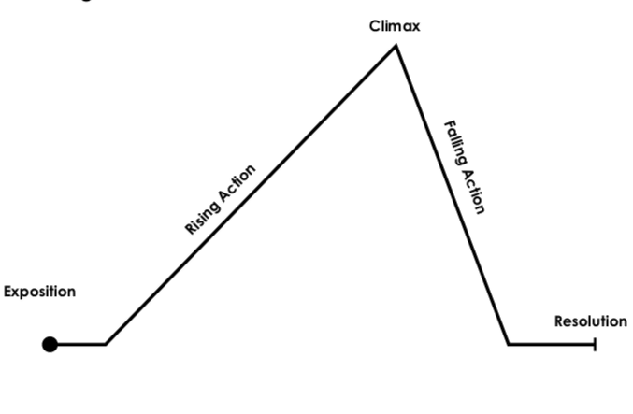

Identify the following:
- Exposition
________________________________________________________________________________________________________________________________________________
- Conflict
________________________________________________________________________________________________________________________________________________
- Rising Action
________________________________________________________________________________________________________________________________________________
- Climax
________________________________________________________________________________________________________________________________________________
- Falling Action
__________________________________________________________________________________________________________________________
- Resolution
__________________________________________________________________________________________________________________________

