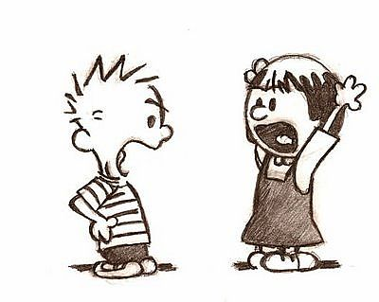
Types of Conflict
Conflict:____________________________________________________________
Person vs. Person
Person vs. Self
Person vs. Nature
___________________________________________________________________
___________________________________________________________________

