Name:
How do People Organize Themselves in a Society?
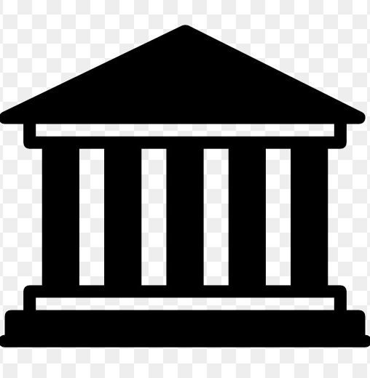
Throughout this unit, you have learned that societies have organized themselves in a variety of ways according to the needs and values of their people. All societies need a foundation of government and law to create order in this society. Governments are in charge of addressing issues that people are concerned about. One major issue that is important to many governments today is climate change. How will your island respond to the growing concerns of its citizens?

TO SHOW YOUR UNDERSTANDING OF THIS QUESTION, YOU MUST COMPLETE AT LEAST THE FIRST TWO ASSIGNMENTS. The more assignments you complete, the more points you can earn based on the quality of the assignment you submit. USE THE CHECKLIST TO MAKE SURE YOU ARE DONE EVERYTHING, then complete the self-assessment!

My Government:________________________________________________

NEED TO DO
(Your mark on this project contributes to your team’s points!)
A constitution is a written document that says how a government should run its country. It is made up of several articles from which laws are passed that the government and people must follow. Use the template provided to write a two column constitution for your island (refer to your textbook for information). Your constitution should include the following articles:

- Article 1 - Who makes decisions on your island and what are they called? Who decides on this person/group of people and how?
  - Compare to Ancient Greece

- Article 2 - What are the 5 most important responsibilities of your government?
  - Compare to Ancient China

- Article 3 - How does your government value its people? (Think - how are people treated?)
  - Compare to Ancient Egypt or India

- Article 4 - What are 5 rights of your citizens? What are 5 responsibilities of your citizens?
  - Compare to Ancient Rome

- Article 5 - write 5 laws of your island and an appropriate punishment if they are not followed.
  - Compare to Ancient Mesopotamia

- Addendum 6 - Answer these questions: What does a fair government look like? Is your island’s government fair - why or why not? Then choose an ancient civilization of your choice and say whether or not its’ government was fair, why or why not?

- Article 7 - write a policy on climate change and the environment. Policy must include;
  - a) greenhouse gas emissions and what your island is doing to reduce them.
  - b) a second policy on water conservation OR sustainability of natural resources OR sustainability of food production.

- Article 8- write a policy on emergency response to address preparedness for natural disasters related to climate change. What natural disasters is your island vulnerable to because of climate change? What is your government doing to prepare its citizens and/or respond to the disaster?
CAN DO
(Your mark on these bonus projects contributes to your team’s points!)
Draw an image of your government building on your island. This could be either the interior or exterior of the building. Include important artwork/statues that are important to the history of your island that explain your structures historical significance. Label your images where necessary. | Come up with a plan about how your island will deal with the “plastic crisis”. Will you use alternate materials, ban plastic, have recycling programs, fine companies that use single use items? Explain your plan in 11 x 17 poster form.
Pick a modern day country and research its government. Answers these questions:  - Who is the leader and what are they called?  - How is that person chosen?  - Do you think how they choose their leader is fair?  - List 3 laws of this country.  - Title of country name and draw flag at top. | What would you like to learn about climate change? Come up with some questions that you would like to know more about (similar to term 1 genius hour). Get your questions approved by a BIPS science teacher. State your question, research your question and write notes, create a presentation, and present it to two of the Team BIPS teachers.

