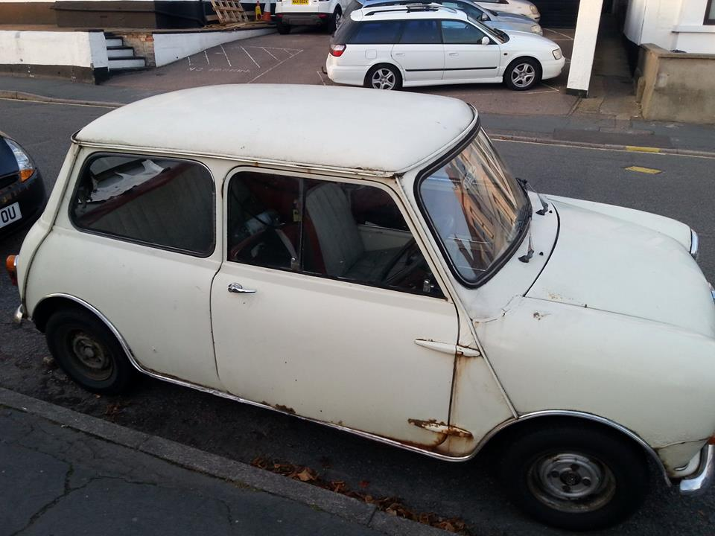

Life Changing Car For Sale!

FOR SALE! I, Chuck Norris, am selling my 1945 Volkswagen Beetle and, let me tell you, owning this car will change your life. It changed my life and changing my life is more difficult than solving a Rubik's cube blindfolded with your feet (I should know because I have done this many times before). This car has been in my family for three generations and it is more reliable than the rising and setting of the sun. My father, Chuck Norris Sr., drove this car faster than an interstellar spacecraft transcending space and time. It is as strong as steel and as compact as one of those fancy Japanese cube hotel rooms. It is clean like one of my swift karate chops that knocked Jean-Claude Van Damme out of the ring. The wheels on this beauty are the revolving doors of life after a swift kick by myself, Chuck Norris; they never stop spinning. The engine is a bearded dragon, breathing fire out of its nostrils like my beard breaths fire out of its… hair. Driving this car will make you a champion as you feel your hands grip the rubber wheel, your feet touching the smooth pedals. "Drive this," my father once told me "and you will truly belong to the Norris family. You will be able to count to infinity, twice." Imagine the wind whooshing through your roughly trimmed beard as you turn into the McDonald's drive-thru in this masterpiece of innovation. This car is the envy of all, its omnipotence will be felt from street to street. Bang is the sound you will hear as the sound barrier breaks as you exit your driveway. Buy this car… You will not be disappointed! If you don't, Jean Claude Van Damme, Batman, Emmet from the Lego Movie, and myself will all find you and give you a swift karate kick to the elbow.
-Chuck Norris
Phone Number - 1

