Avengers Endgame Review
By: Mr. Butterworth

Avengers Endgame is the final installment of the Avengers series. There are many different characters in the movie that make up the Avengers cast, such as Ironman, Spiderman, Hulk, Thor, and Black Widow. The movie takes place in a variety of settings, such as Earth and space, as well as different timelines. The movie pits the Avengers against the mighty Thanos as they try to reverse the effects of his victory in the previous movie. The Avengers travel back in time to gather all of the infinity stones back in their present time, which they succeed. Unfortunately, Thanos tracks them back to Earth, leading to a massive final battle where Thanos is ultimately defeated.
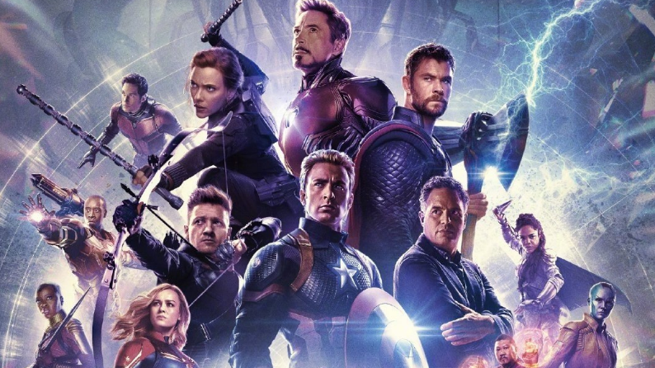

If you enjoy action and adventure movies, then this movie is definitely for you. It is widely considered a modern cinematic masterpiece, combining stunts, CGI, and a well-written screenplay to create a fun and edge of your seat experience for viewers. Each character gets an appropriate amount of screen time and, since we know the character's background stories well enough, the audience feels like they are going on this quest with the heroes themselves. It will bring you to tears, it will make you cover your eyes, and it will give you that feeling of satisfaction – this movie is not to be missed. Ultimately, it is an excellent conclusion to the Avengers series and brings all elements of the universe together for a satisfying and exciting conclusion.

