How to Change Your Desktop Background
By Mr. Butterworth

Your computer’s desktop background is a very important part of your computer experience. This is a picture that you will see every time you log in. If this picture is personalized to what you like, you will enjoy your computer more.

- Step 1 – Decide on what type of image you would like for your desktop background.
  - This can be something from your favourite TV show or Movie, or any other topic you can think of.
- Step 2 – Open an internet search engine.
  - Open up Google on your web browser. You can also use other search engines if you’d like, such as Bing and Yahoo.
- Step 3 – In the search bar, type in an image you would like to search for.
  - This image will become your desktop background.
- Step 4 – Click on "images".
  - Instead of searching for websites, you need to be searching for images.
- Step 5 – Click on "Tools" and change the size of your image to "Large"
  - The "Tools" option will allow you to customize your search options when looking for images for your desktop background.
- Step 6 – Click on a picture that you would like to use for your desktop background.
  - Find one that you like!
- Step 7 – Right click on that picture and select "Set as Desktop Background".
  - If this doesn't work, you may need to download the picture first by clicking on "Save Picture As". Once the picture is downloaded, right click on your desktop screen and select personalize.
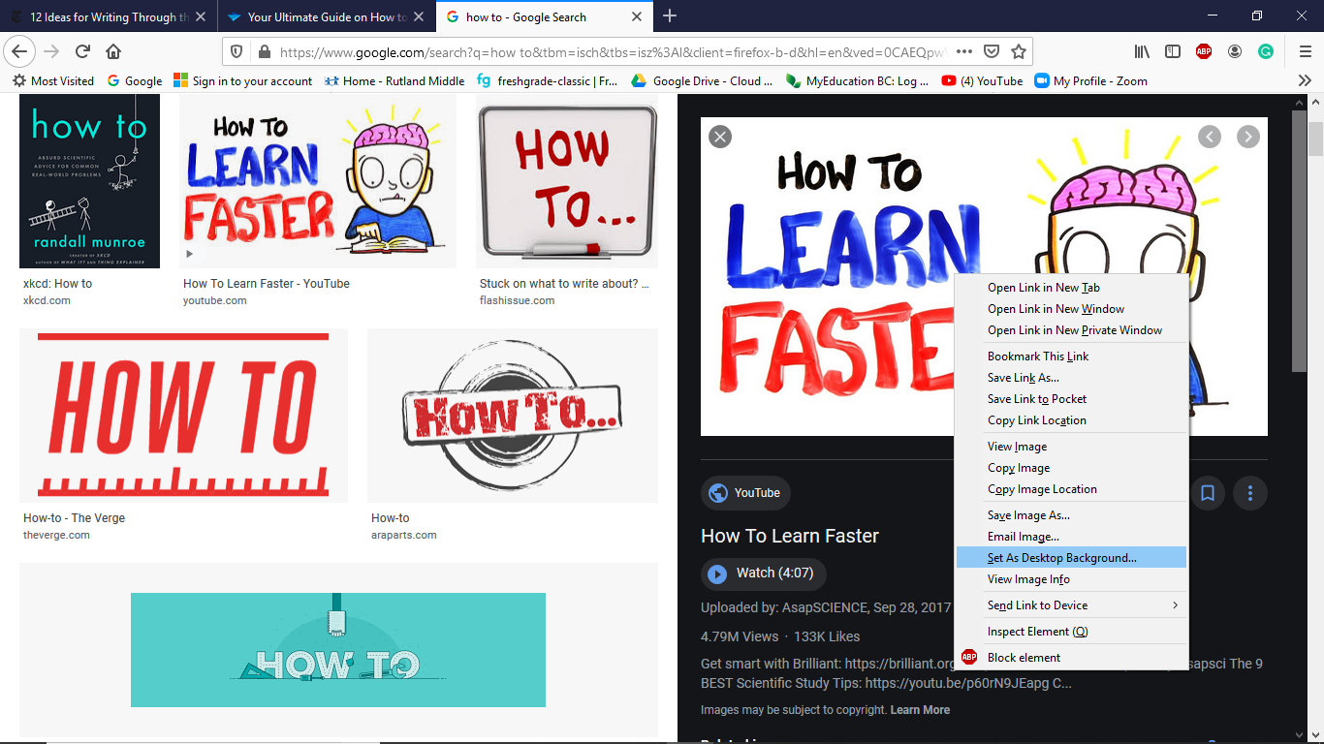
- Step 8 – View your desktop background.
  - To quickly view your desktop background, click on the widget in the bottom right hand quarter of your screen.
- Step 9 – You can also use a personal photo loaded onto your computer as your desktop background by right-clicking on the photo and selecting set as desktop background.
  - You may need to change the size or orientation of the photo to ensure that it fits.
- Step 10 – Enjoy your new desktop background!
  - There are lots of cool pictures out there that can be used as desktop backgrounds.

