Lionel Messi
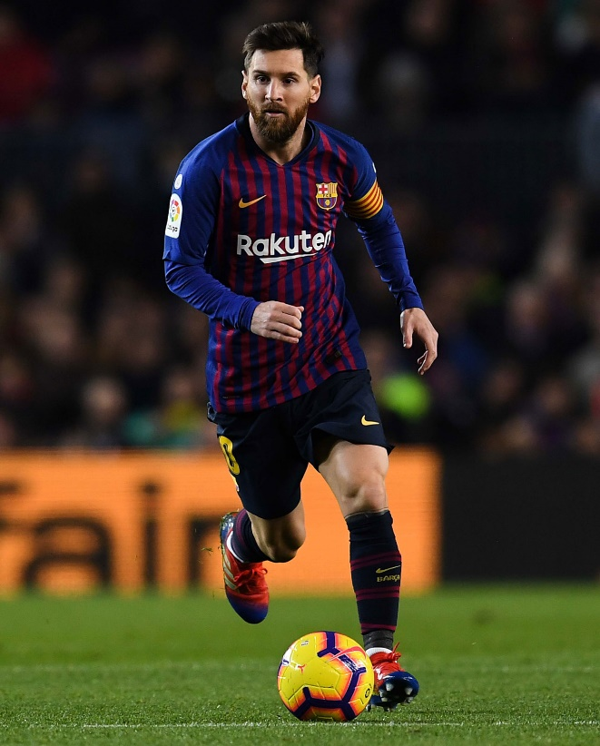
Date of Birth: June 24, 1987
Place of Birth: Rosario, Argentina
Character Trait: Creative
Character Trait: Driven

CHILDHOOD LIFE
Growing up, Messi had two older brothers who he would often play soccer with. Even though he was smaller than them, he wasn't intimidated by their size. Eventually, Messi was diagnosed with a hormone deficiency, which explained his small stature. His parents, Jorge and Ceclia, helped support their sign by paying for nightly hormone injections.
Messi started playing football early as a child and his first team was Newell's Old Boys youth squad. From a young age, Messi displayed amazing skills that were considered to be generational. He quickly attracted the attention of top-level teams and at the age of 13, Messi and his family moved to Barcelona, Spain.

MAJOR LIFE EVENTS
Messi had many accomplishments that make him one of the most well known soccer players of all time. The first is that, in 2005, he became the youngest player to ever score a goal for the Barcelona team. On May 1, he scored against Albacete on an assist from Ronaldinho.
A big accomplishment in soccer is winning the Champions League Trophy. Messi led Barcelona to their first champions league trophy in 2006 in their victory against Arsenal. His outstanding play and leadership helped to lead his squad to victory and many more Champions League titles in the future.
Another major life event for Messi was that in 2007 he created the Leo Messi foundation to help support disadvantaged children. Messi believes that all children should have the same opportunities to realize their dreams and has raised hundreds of thousands of euros to help children around the world.

WHY THEY ARE IMPORTANT
Messi is an important figure in soccer mainly because he is considered to be one of the best players in the history of the game. He has scored among the most goals in history and has led his team, Barcelona, to decades of success. He is also an important inspirational figure to people around the globe. Many children look up to Messi, buying his jersey and watching his games, which promotes the growth of the sport internationally. Messi's play also revolutionized how soccer is played. His quick feet, passing, and scoring ability changed how teams attack, and defend, in modern soccer.

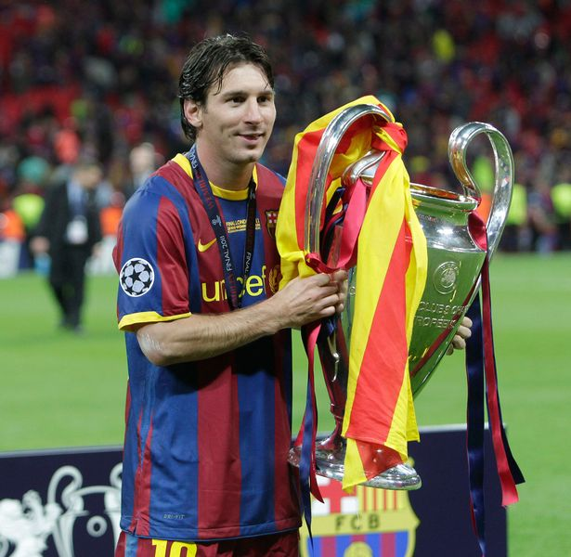
*NOTE – THIS IS JUST AN EXAMPLE OF A TEMPLATE! FEEL FREE TO USE THIS TEMPLATE ON GOOGLE DOCS, CHANGE IT, CHANGE THE COLOURS, OR CREATE YOUR OWN!

